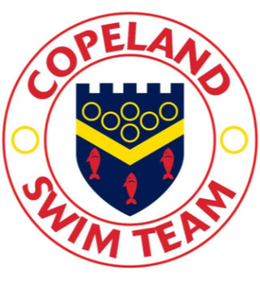 **Rankings and Qualifications** 

**How does a swimmer gain a qualification time or a personal best?**

To gain a personal best time, a swimmer must compete in a licenced gala. Once the swimmer has competed in a licenced gala, they will have official times and rankings on the Swim England website. A link can be found on the Copeland ASC website that records personal best times, progress graphs and other useful information.

There are four levels of licenced gala; level four tends to be club galas. Level three, two and one, cover galas that progress through County, Regional and National level.

Swimmers must achieve the qualifying time to be able to compete at certain galas. Galas are often targeted at a specific group of swimmers by specifying upper and lower qualifying times. This system ensures that all levels of competitive swimmer are catered for.

**How does a swimmer get selected for the County?**

County selection is decided from the individual swimmers ranking against the rest of their age group. Typically, the top two swimmers from each age group in each event will be selected to represent Cumbria. A swimmer will also have a maximum number of swims in which they are allowed to compete. County selection will take place and swimmers will be informed through the club.

**How does a swimmer qualify for Age Group, Regional and National competitions?**

Age group and Regional competitions have published qualifying times that have to be achieved between certain dates. Once a swimmer has achieved a qualification time they can enter the chosen gala. The club will inform the swimmer when they have achieved qualification times for these events.

National qualification is achieved via ranking with the top fifty swimmers in the UK being invited to swim at either the English or British Nationals event.