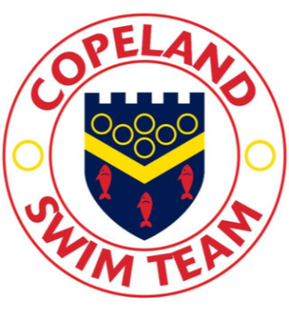 The Training program
Copeland ASC has adopted a cyclical seven week training program that covers technique, recovery, strength, speed and endurance. Using this program, the club can give each swimmer the best chance of performing to their potential.
The training program has been aligned with the competition calendar to ensure that each swimmer arrives at the targeted gala fully prepared. The competition calendar is designed to give swimmers of all abilities the chance to compete at the appropriate level of competition. Galas are either targeted or optional. The targeted galas are fully supported by the club, providing coaches and poolside helpers to assist the swimmers. Optional galas may be supported by the club if resources allow.
Land training
Land training is offered to swimmers as part of the training program to supplement pool time. Swimmers will work on balance, co-ordination, flexibility, core strength and overall fitness. Swimmers of any age can attend the land based training session but should speak to the Head Coach before doing so.
Equipment
Swimmers should bring goggles and a cap. Swimmers with long hair must wear a cap during training. Swimmers should also bring a 700ml bottle for each hour of training they attend to ensure they remain hydrated. Drinking a 7ooml bottle before and after training is also recommended.
Although the pool does provide some equipment, swimmers should have access to a float, a size proportional pull buoy, fins, snorkel and hand paddles. The Head coach will inform the swimmers when they are allowed to use drag shorts and hand paddles.
Timekeeping
Swimmers should report to pool side 10 minutes prior to the session start time to allow time to mobilise. Swimmers will carry out exercises to warm up prior to entering the pool, and will continue the warm up in the pool. Following completion of the program, swimmers will cool down in the water and may stretch on pool side before the session ends.

